Using Jenkins and AWS cli configured the following task:
Create ECS cluster,
Task definition
Register Task definition in Service
Configure service in target group
Deploy a web application on ECS Optimised image t2.small instance.

There are many ways in which this task can be configured
Here I have done the task using AWS CloudFormation first and then using AWS CLI

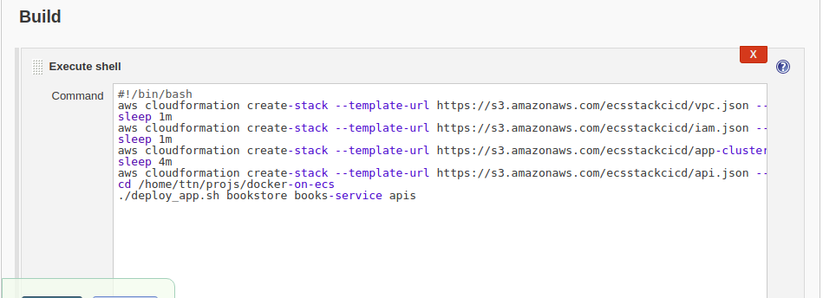

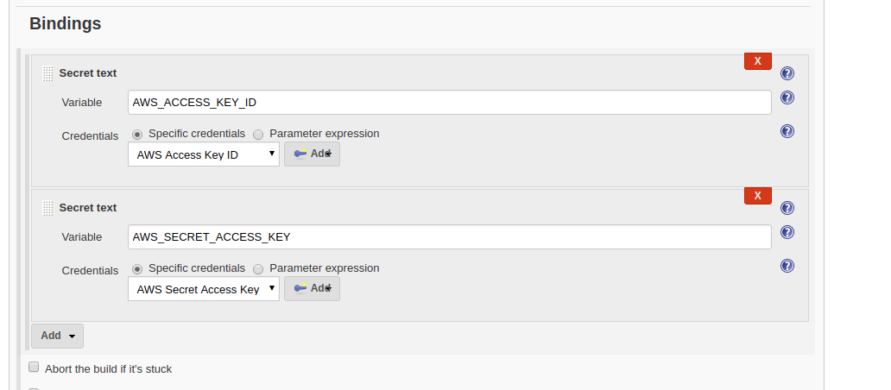

The json template for the Cloudformation stack is picked from AWS S3 bucket
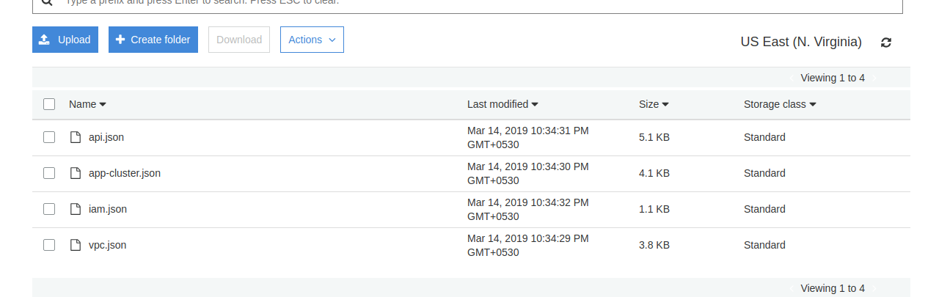
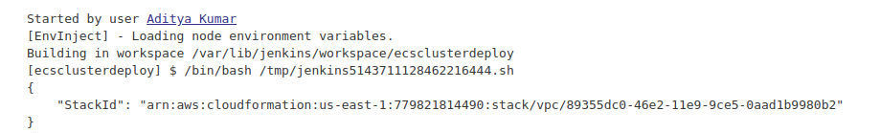

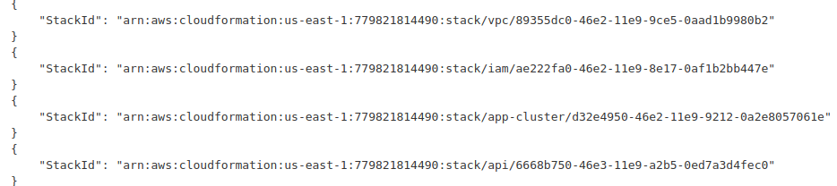
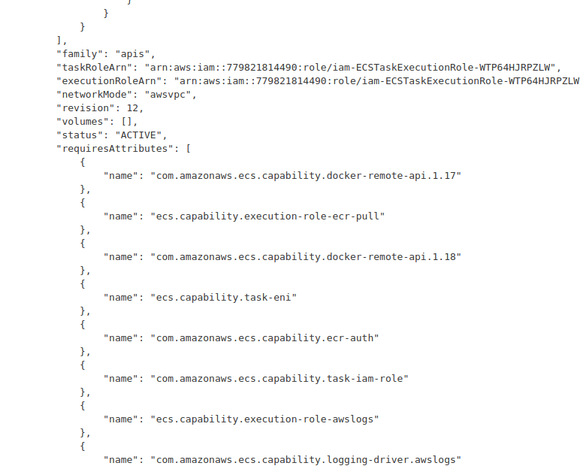
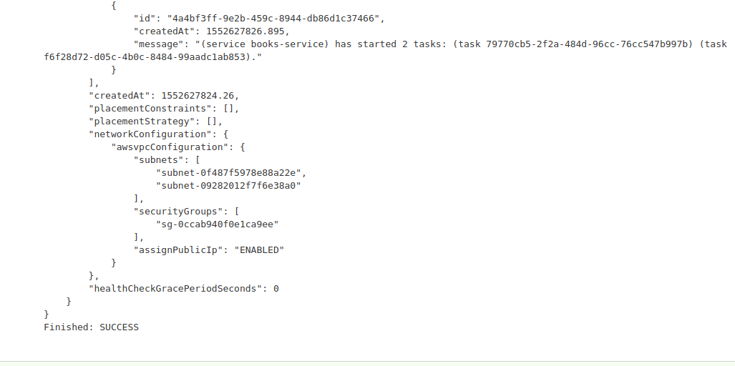
The code for the json file can be seen on the same github repository
https://github.com/ttn-aditya/bootcamp19_exercises/tree/master/ECS%2007-03-2019/CloudFormation%20Template

Now the same things are done using AWS CLI

#!/bin/bash

aws ecs create-cluster --cluster-name AdityaCluster

printf '#!/bin/bash\nECS_CLUSTER=AdityaCluster" >> /etc/ecs/ecs.config ' > userdata.txt

ec2ID=`aws ec2 run-instances --image-id ami-0a6a36557ea3b9859 --count 1 --instance-type t2.micro --key-name adityakumar --iam-instance-profile Name="aditya-ecs" --user-data file://userdata.txt --subnet-id subnet-0a5c1e53 --security-group-ids sg-08a47a9252b7191c8 --query 'Instances[].InstanceId' --output text`
sleep 3m

tgarn=`aws elbv2 create-target-group --name Aditya-tg1 --protocol HTTP --port 8080 --vpc-id vpc-d38d68b7 --query 'TargetGroups[].TargetGroupArn' --output text`

aws elbv2 register-targets --target-group-arn ${tgarn} --targets Id=${ec2ID}

lbarn=`aws elbv2 create-load-balancer --name Aditya-alb --subnets subnet-319fe81a subnet-5efae264 --security-groups sg-08a47a9252b7191c8 --query 'LoadBalancers[].LoadBalancerArn' --output text`
aws elbv2 create-listener --load-balancer-arn ${lbarn} --protocol HTTP --port 80 --default-actions Type=forward,TargetGroupArn=${tgarn}

aws ecs register-task-definition --network-mode bridge --family nginx --volumes "[{\"name\": \"test\",\"host\": {\"sourcePath\": \"/var/log\"}}]" --container-definitions "[{\"name\":\"test\",\"image\":\"nginx\",\"cpu\":256,\"memory\":256,\"essential\":true, \"portMappings\":[{\"hostPort\":80,\"containerPort\":80,\"protocol\":\"tcp\"}],\"logConfiguration\":{\"logDriver\":\"awslogs\",\"options\":{\"awslogs-group\":\"awslogs-nginx-ecs\",\"awslogs-region\":\"us-east-1\", \"awslogs-stream-prefix\":\"nginx\"}}, \"mountPoints\": [{\"sourceVolume\":\"test\",\"containerPath\":\"/var/log\",\"readOnly\":false}]}]"

aws ecs create-service --service-name Aditya-nginx --cluster AdityaCluster --task-definition nginx --desired-count 1 --load-balancers "[{\"targetGroupArn\":\"${tgarn}\",\"containerName\":\"test\", \"containerPort\":80}]" --role ecsServiceRole

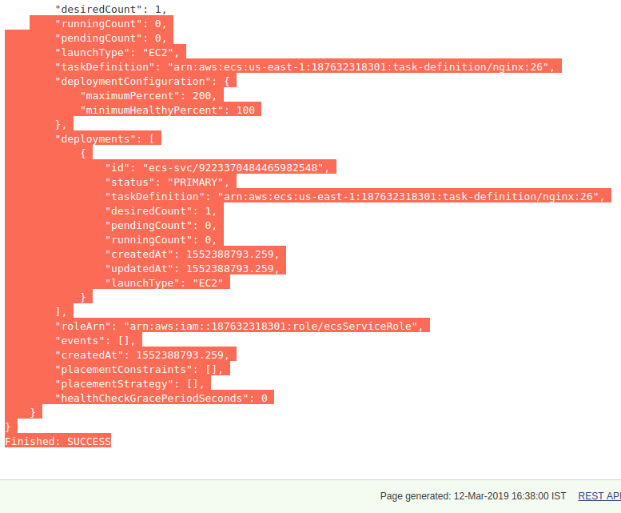

Evaluate different orchestration tools.

There are many orchestration tools present the open source market .
Some of them are such as Kubernetes,Puppet,Chef ,Ansible .
These tools are helpful in automating tasks and making the life of DevOps Engineers easier .
Orchestration is the automated configuration , and management of computer system and software

